Research Report: Unrestricted Access and Sensitive Business Flows

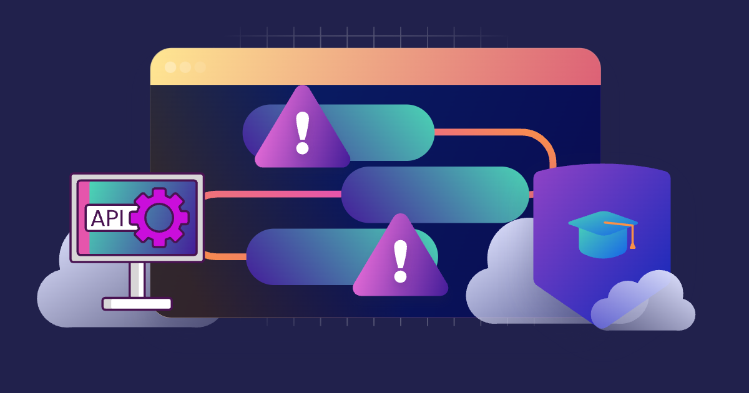

Introduction
Unrestricted access and sensitive business flows are critical security concerns in modern applications and systems. When access controls are weak or improperly implemented, malicious actors can exploit these vulnerabilities to compromise sensitive business operations, leading to financial losses, reputational damage, and regulatory penalties. This report explores these issues, their impacts, and mitigation strategies.

What is Unrestricted Access and Sensitive Business Flows?
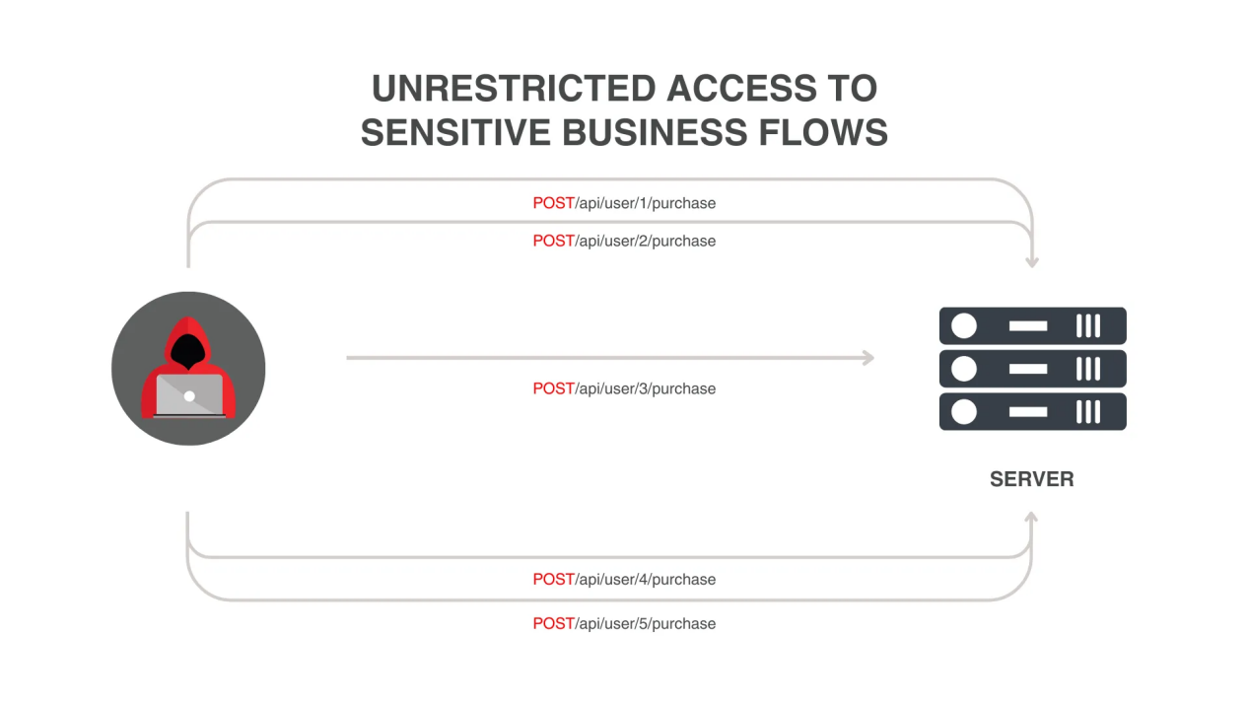

Unrestricted Access:
Unrestricted access refers to the failure to enforce appropriate access controls, allowing unauthorized users to interact with or manipulate resources, data, or functionality that they should not have access to.

Sensitive Business Flows:
Sensitive business flows are critical processes or operations that handle valuable or confidential business data, such as financial transactions, user authentication, or proprietary workflows. Exploiting these flows can result in significant harm to an organization.

Example or Case Study

Case Study: API Misconfiguration in Payment Systems
Scenario: An e-commerce platform’s payment API lacked proper access controls. An attacker discovered that by altering request parameters, they could modify payment amounts or cancel transactions without proper authorization.
Impact:
- Unauthorized transactions caused financial losses.
- Customers lost trust in the platform’s security.
- Regulatory scrutiny and potential fines.
Mitigation:
- Implementing strict role-based access controls.
- Validating all input parameters and enforcing business rules in the backend.

Impact of Unrestricted Access and Sensitive Business Flows
- Financial Loss: Exploitation can lead to unauthorized transactions, fraud, and monetary damage.
- Data Breach: Exposure of sensitive data like customer information or proprietary business logic.
- Operational Disruption: Interruption of critical workflows or processes.
- Reputational Damage: Loss of trust among customers, partners, and stakeholders.
- Regulatory Penalties: Non-compliance with laws like GDPR or PCI-DSS can result in fines and legal action.

Mitigation Measures
Access Control Policies:
  - Use role-based or attribute-based access controls (RBAC/ABAC).
  - Enforce least privilege principles to restrict access to only what is necessary.
Secure Design and Development:
  - Conduct threat modeling to identify sensitive business flows.
  - Implement input validation and output encoding to prevent tampering.
Authentication and Authorization:
  - Use multi-factor authentication (MFA).
  - Validate tokens or credentials for all sensitive operations.
Monitoring and Auditing:
  - Log and monitor access to sensitive operations.
  - Use anomaly detection to identify unusual activity.
Penetration Testing and Code Reviews:
  - Perform regular security assessments.
  - Identify and fix vulnerabilities in sensitive business processes.
Education and Awareness:
  - Train developers and employees on secure coding practices.
  - Raise awareness about the importance of protecting sensitive flows.

Conclusion
Unrestricted access and the exploitation of sensitive business flows pose significant risks to organizations. By implementing robust access controls, securing critical workflows, and monitoring activity, organizations can mitigate these risks effectively. Prioritizing security in system design and ongoing operations is key to safeguarding business integrity and customer trust.

References
- OWASP Top 10: Broken Access Control
- NIST Special Publication 800-53: Access Control Guidelines
- "Securing APIs: Best Practices," Tech Security Journal.
- Case Study: API Vulnerabilities and Their Mitigation, InfoSec Research Papers.

